Cit Pecyn Ymarfer a Gweithgareddau (Gogledd) Uned 4
Practice and Activity Pack (Gogledd) Unit 4

A. Be’ maen nhw’n wneud?
What do they do?
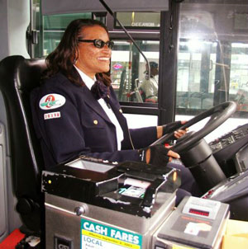

meddyg _________ __________ _________ ____________

__________ ______

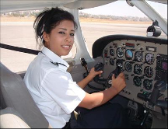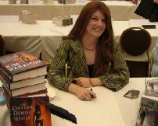

____________ __________ __________

B. Llenwch y bylchau
Fill in the gaps

Nyrs ____ ______?  ____. _____ ydy____. |  | ____________ ____ hwn?  ________. ______ cogydd  _____ ____. | 

Lle ______ Mr Hughes ____ __________________?

______ _____ gweithio ________ siop.

Lle maen _________  __________________?  ____ Sainsburys. |  |  | ______ Sharon ____ coginio?  ______. |  | 
Ydy ____ siarad ar y ffôn?  ______ ______. Mae o’n __________. |  | 

________ ____ dy ______ ____? Lowri dw i.

________ ____ ________ ______ chi? Harri ____ __.

C. Atebwch
Answer

Wyt ti’n gweithio? ______________.

__________________________________________________.

(If you do...)
Lle wyt ti’n gweithio?

__________________________________________________________________

Efo’ch plentyn
With your child

1. Galwedigaethau/Occupations
- Cut out the person/activity cards on the next page. Fold each one down the solid line, and divide them equally between the players. Each player puts one of their cards on the table with the occupation side facing towards themselves (other players must not see), and the name side facing the other players
- Each player tries to guess the occupation of the person on the card, by asking Nyrs ydy Siân? Cogydd ydy hi? Dawnsiwr ydy hi? and so on. The other player answers Naci. Dim nyrs ydy hi and so on until somebody guesses the occupation.
- One person should keep score: the card holder gets one point for each question to which he/she answers Naci.

2. Beth maen nhw’n wneud?/What are they doing?
- Prepare a few of your child’s toy characters, and a pile of activity cards (cysgu etc) from the course card pack. In turn, players take a card from the pile, which only they see, and they ‘assign’ it to a toy (or a group of toys) of their choice.
- Other players must guess what the toy is doing:Ydy Bobs yn chwarae pêl droed? Ydy o/hi’n dawnsio? Ydy/Nac ydy! (Only short answers are possible at the moment, as we have yet to learn the negative forms). When talking about two or more characters: Ydy Fflic a Fflac yn bwyta? Ydyn nhw’n mynd am dro? Ydyn/Nac ydyn!
- Again, one person can keep score. The card holder gets one point for each question to which the answer is negative.

 | 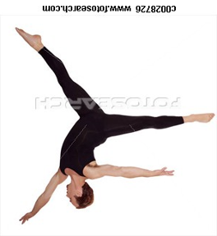 |  |  | 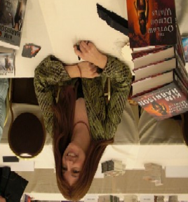
Mandi   | Ceri   | Alun   | Bob   | Kim  
 |   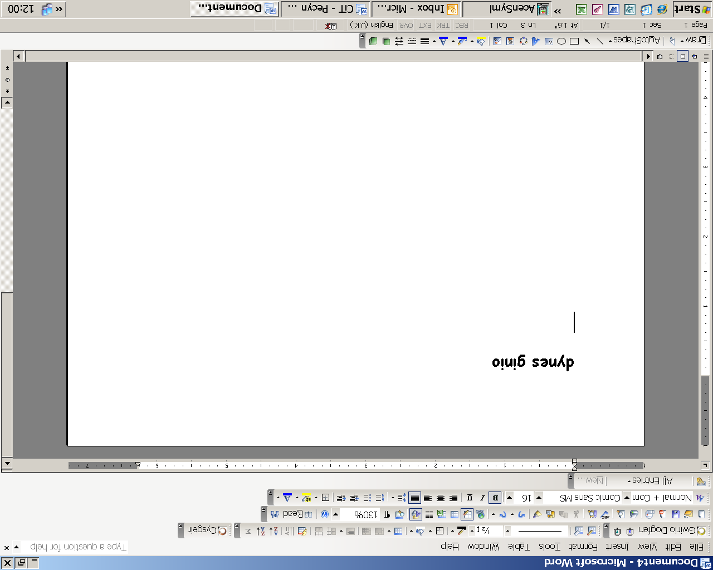 | 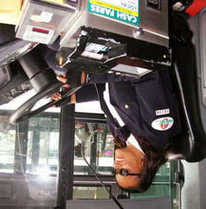 | 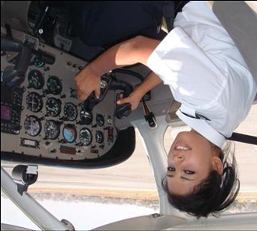 | 
Mrs Roberts   | Mair   | Donald | Carys   | Eurwen  

